How to commit code in GIT

1)Install Git Bash from the path(\\10.141.104.46\share\Vishnu) (Git-2.43.0-64-bit)
2)Create a Branch in git web app
Login into Git Site:
https://gitprd.ib.in/dlp/dlp_application
username : dlpng@indianbank.co.in
password : lck1234@#
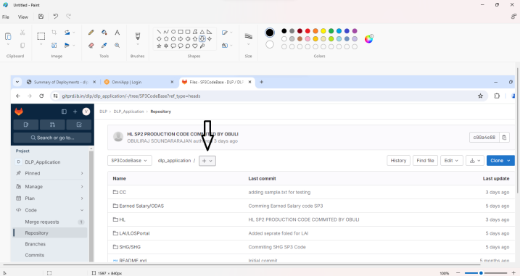
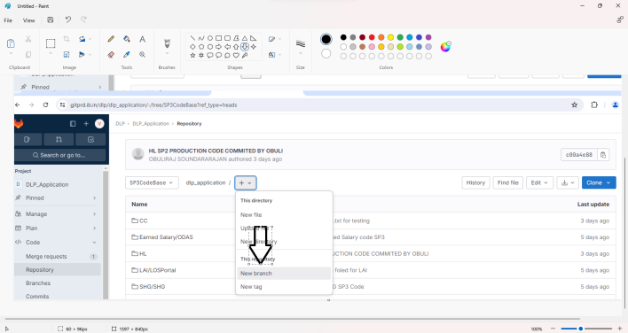
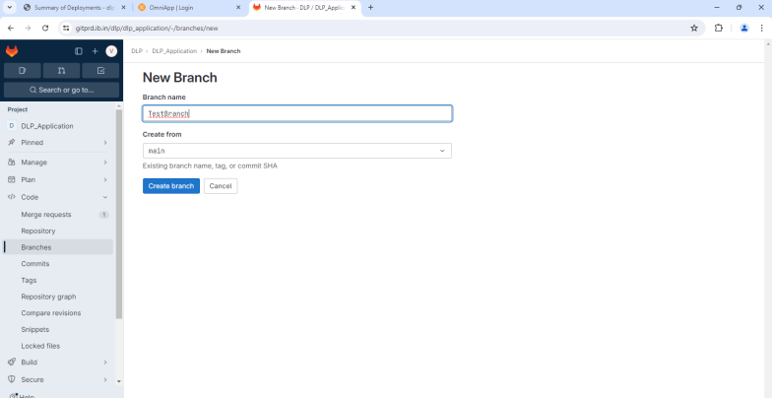

3)
Create a folder for Git in local
Open Git Bash (Right click mouse)
Go to your path in Git Bash
cd Git Folder/
Follow the steps:
git init
git config --global http.sslVerify false
git clone -b branch https://gitprd.ib.in/dlp/dlp_application.git
User name password will be asked
username : dlpng@indianbank.co.in
password : lck1234@#
Go to your Repository Path
cd dlp_application/
Drag the Code inside the git repository(dlp_application) in local.
4)Do the following
git status
git add Folder/
git commit -m "Your Comment" (Must Commit with comments)
git push

*To delete a folder or file*
rm -r Folder/
git add Folder/
git commit -m ""
git push
*To delete a folder or file*

*To pull a particular file*
git pull origin Branch
*To pull a particular file*

For my git hub steps I used
Folder creation in local
Git basg CMD :
git init
git clone https://github.com/poorna-chandu123/Springboot_Basic_Topic_Projects.git
git config --global http.sslVerify true
Next folder creation projects moving

Nice — let’s keep this very simple and do it fresh exactly the way you asked.
You already created the remote and you already have a local path:
Remote repo: https://github.com/poorna-chandu123/Spring_boot_basic_projects_Repo.git
Local folder: D:\GIT_Main\Spring_boot_basic_projects_Repo_Local
Short answer to your question first:
Create the .gitignore before you add/commit your projects.
That prevents build files, target/, IDE files, jars, etc. from ever being added.
Below are the exact step-by-step commands to run in Git Bash (Windows). Copy–paste them one-by-one.

1 — Open Git Bash and go to your local folder
cd /d/GIT_Main/Spring_boot_basic_projects_Repo_Local
If the folder does not exist yet, create it first:
mkdir -p /d/GIT_Main/Spring_boot_basic_projects_Repo_Local
cd /d/GIT_Main/Spring_boot_basic_projects_Repo_Local

2 — Initialize git and set main branch
git init
git branch -M main

3 — Create a good Spring Boot .gitignore now (before adding projects)
Create the file with this content (recommended for Maven/Gradle + IntelliJ/Eclipse):
cat > .gitignore <<'EOF'
# Build folders
/target/
/build/

# Maven wrapper
.mvn/

# IDEs
/.idea/
/*.iml
.classpath
.project
.settings/
/.vscode/

# Logs and temp
*.log
*.tmp
*.swp
*~

# Compiled and packaged files
*.class
*.jar
*.war
*.ear

# OS files
.DS_Store
Thumbs.db

# Node
node_modules/

# Env
.env
EOF
(You can edit this later if you want more/less.)

4 — Add remote (connect to GitHub)
git remote add origin https://github.com/poorna-chandu123/Spring_boot_basic_projects_Repo.git
git remote -v # verify it shows origin for fetch and push

5 — Now add files and commit (first commit)
If you have already copied projects into this folder, run:
git add . # respects .gitignore so ignored files won't be staged
git commit -m "Initial commit: add .gitignore and project skeleton"
If you haven’t yet copied any projects, you can still commit .gitignore first:
git add .gitignore
git commit -m "chore: add .gitignore"

6 — Push to GitHub
git push -u origin main
When prompted for credentials: use your GitHub username and a Personal Access Token (PAT) as the password for HTTPS.
If you prefer SSH (no PAT prompts), set up SSH keys and change the remote to the SSH URL — I can give those steps if you want.

7 — Later: add new Spring Boot projects (recommended workflow)
Create a new project folder inside the repo, e.g. JPA_Project:
mkdir JPA_Project
Add your project files into that folder (copy or create).
Stage, commit, push:
git add JPA_Project
git commit -m "feat: add JPA example project"
git push
Or add multiple at once:
git add .
git commit -m "add several spring boot projects"
git push

8 — If you accidentally committed build/IDE files BEFORE adding .gitignore
Don’t worry — fix it with these commands:
# ensure .gitignore is correct and committed
git add .gitignore
git commit -m "chore: add .gitignore"

# remove all files from index and re-add (won't delete local files)
git rm -r --cached .
git add .
git commit -m "chore: remove ignored files from tracking"

# push fixes
git push
That removes the previously tracked ignored files from the repo history going forward (files stay on your disk).

Quick checklist for you
.gitignore created before adding projects (recommended)
git init done and remote origin added
git add . → git commit → git push -u origin main done
Add projects into folders later, then git add → commit → push
If you want, I can now:
Give the exact .gitignore tuned for Maven + IntelliJ specifically, or
Show how to create a GitHub PAT step-by-step, or
Give the SSH steps instead (no PAT).
Which of those would you like next?

